Declaration of Conformity (DoC)

We,Shenzhen DOKE Electronic Co.,Ltd.
801, Building3, 7th Industrial Zone, Yulv Community, Yutang Road, Guangming District, Shenzhen, China.

Declare that the DoC is issued under our sole responsibility and belongs to the following product(s):
Product Type: | Mobile Phone
Trademark： | Blackview, OSCAL
Model Number(s): | SHARK 6, TIGER 8
(Name of product, type or model, batch or serial number)

System components:
For BT/BLE/2.4G WIFI/5G WIFI/NFC/GNSS/GSM/WCDMA/LTE/5G NR: FPC Antenna
For FM: Integral Antenna/BT/BLE/2.4G WIFI: 0.66dBi
5G WIFI: 1.62dBi
E-GSM 900/GPRS 900/EGPRS 900: -2.82dBi
GSM 1800/GPRS 1800/EGPRS 1800: 0.77dBi
WCDMA Band I: 0.66dBi
WCDMA Band VIII: -2.82dBi
LTE band 1: 0.66dBi
LTE band 3: 0.77dBi
LTE band 7: 2.33dBi
LTE band 8: -2.82dBi
LTE band 20: -1.77dBi
LTE band 28: -3.18dBi
NR n1: 0.66dBi
NR n3: 0.77dBi
NR n8: -2.82dBi
NR n20: -1.77dBi
NR n28: -3.18dBi
NR n40: 1.78dBi
NR n77: -0.72dBi
NR n78: 0.82dBi
Adapter Information:
Model: QZ-0180AEA00
Input: AC 100-240V, 50/60Hz, 0.5A
Output: DC 5.0V, 3.0A, 15.0W or DC 9.0V, 2.0A, 18.0W or DC 12.0V, 1.5A, 18.0W
Manufacturer: Guangdong Quanzhi Technology Co.,Ltd.

Rechargeable Li-ion Battery:
Model: Li456788PLGY; Specification: 3.89V, 5000mAh, 19.45Wh;
Manufacturer: Hunan Gaoyuan Battery Co., Ltd.
USB Cable:100cm
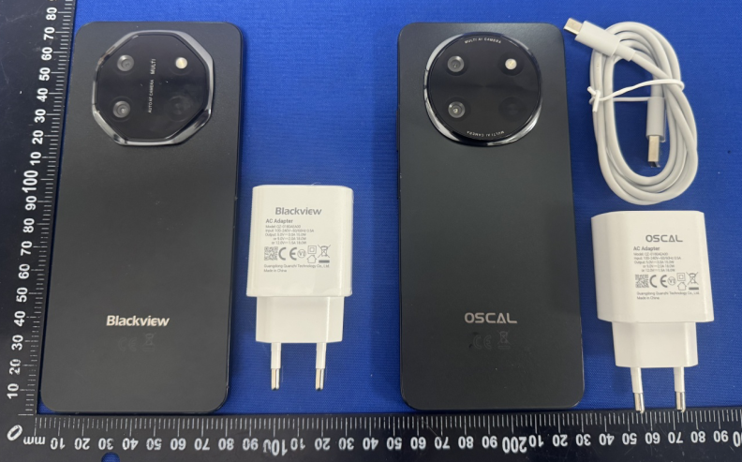

The object of the declaration described above is in conformity with the essential requirements of the relevant Union harmonization legislation: Radio Equipment Directive RED (2014/53/EU).

The following harmonized standards and technical specifications have been applied:

HEALTH & SAFETY (Art. 3(1)(a)):

EN 50566:2017+A1:2023

EN 50663:2017

EN IEC/IEEE 62209-1528:2021

EN 50360:2017+A1:2023

EN 62479:2010

EN IEC 62311:2020

EN IEC 62368-1:2020+A11:2020

EMC (Art. 3(1)(b)):

ETSI EN 301 489-52 V1.3.1 (2024-11)

ETSI EN 301 489-19 V2.2.1 (2022-09)

ETSI EN 301 489-17 V3.3.1 (2024-09)

ETSI EN 301 489-3 V2.3.2 (2023-01)

ETSI EN 301 489-1 V2.2.3 (2019-11)

EN 55032:2015+A11:2020+A1:2020

EN 55035:2017+A11:2020

EN IEC 61000-3-2:2019+A1:2021

EN 61000-3-3:2013+A1:2019+A2:2021

Radio Spectrum (Article 3.2):

ETSI EN 300 328 V2.2.2 (2019-07)

ETSI EN 301 893 V2.1.1 (2017-05)

ETSI EN 300 440 V2.2.1 (2018-07)

ETSI EN 300 330 V2.1.1 (2017-02)

ETSI EN 303 413 V1.2.1 (2021-04)

ETSI EN 303 345-1 V1.1.1 (2019-06)

ETSI EN 303 345-3 V1.1.1 (2021-06)

ETSI EN 301 511 V12.5.1 (2017-03)

ETSI EN 301 908-1 V15.2.1 (2023-01)

ETSI EN 301 908-2 V13.1.1 (2020-06)

ETSI EN 301 908-13 V13.2.1 (2022-02)

ETSI EN 301 908-25 V15.1.1 (2024-10)

ETSI TS 138 521-1 V17.11.0 (2024-01)

ETSI TS 138 521-3 V17.11.0 (2024-01)

Notified Body Involved:

Notified Body Name: DERYCOM CERTIFICATION SERVICES, INC.
Notified Body Number: 3052
Notified Body Assessment Performed: Module B/C on Article 3.1a, 3.1b, 3.2
EU-type examination certificate number: TCT-96
RF Specification:
Function | Operation Frequency | Max RF output power:
BLE | 2402MHz–2480MHz | -0.29 dBm
BT(BR+EDR) | 2402MHz–2480MHz | 7.64 dBm
WIFI 802.11b/g/  n(HT20/40) | 802.11b/g/n(20MHz): 2412~2472MHz;  802.11n(40MHz):2422~2462MHz | 17.89 dBm
Wi-Fi  5.2G(802.11a/n20/n40/ac20/ac40/ac80) | 5150MHz~5250MHz | 13.55 dBm
Wi-Fi  5.8G(802.11a/n20/n40/ac20/ac40/ac80) | 5725MHz~5875MHz | 12.40 dBm
GSM/GPRS/EGPRS 900 | TX:880M‐915MHZ;RX:925M‐960MHZ | 33.26 dBm
GSM/GPRS/EGPRS 1800 | TX:1710M‐1785MHZ;RX:1805M‐1880MHZ | 30.28 dBm
WCDMA B1 | TX:1920-1980MHz;RX:2110-2170MHz | 23.47 dBm
WCDMA B8 | TX: 880-915MHz;RX:925-960MHz | 23.06 dBm
LTE FDD B1 | (UL)1920MHz~1980MHz,(DL)2110MHz~2170MHz | 23.03 dBm
LTE FDD B3 | (UL)1710MHz~1785MHz,(DL)1805MHz~1880MHz | 24.03 dBm
LTE FDD B7 | (UL)2500MHz~2570MHz,(DL)2620MHz~2690MHz | 22.33 dBm
LTE FDD B8 | (UL)880MHz~915MHz,(DL)925MHz~960MHz | 22.83 dBm
LTE FDD B20 | (UL)832MHz~862MHz,(DL)791MHz~821MHz | 23.31 dBm
LTE FDD B28 | (UL)703MHz~748MHz,(DL)758MHz~803MHz | 23.16 dBm
NR n1 | (UL)1920MHz~1980MHz, (DL)2110MHz~2170MHz | 23.59 dBm
NR n3 | (UL)1710MHz~1785MHz, (DL)1805MHz~1880MHz | 24.76 dBm
NR n8 | (UL)880MHz~915MHz, (DL)925MHz~960MHz | 23.12 dBm
NR n20 | (UL)832MHz~862MHz, (DL)791MHz~821MHz | 24.82 dBm
NR n28 | (UL)703MHz~748MHz, (DL)758MHz~803MHz | 24.24 dBm
NR n40 | (UL)2300MHz~2400MHz, (DL)2300MHz~2400MHz | 24.77 dBm
NR n77 | (UL)3300MHz~4200MHz, (DL)3300MHz~4200MHz | 25.88 dBm
NR n78 | (UL)3300MHz~3800MHz, (DL)3300MHz~3800MHz | 25.43 dBm
NFC | 13.56MHz | -23.09 dBuA@10m
FM | Rx: 87.5MHz~108MHz | --
GPS | Rx: 1.57542GHz | --
BDS | Rx:1.561098GHz
Galileo | Rx:1.561098GHz

Tests for SAR are conducted using standard operating positions with the device transmitting at its highest certified power level in all tested frequency bands. The maximum SAR values tested on this device when used in its normal position at the ear and when used close to the body (at a minimum distance of 5mm/0mm) are:
Max SAR Value(W/kg)  Limit is 2.0(W/kg) for 10-g | 10-g Head | 0.28 W/kg
 | 10-g Body | 0.53 W/kg
Limit is 4.0(W/kg) for 10-g | 10-g Member DAS | 1.38 W/kg
Technical file held by:Shenzhen DOKE Electronic Co., Ltd
801, Building3, 7th Industrial Zone, Yulv Community, Yutang Road, Guangming District, Shenzhen, China.

Signed for and on behalf of: Shenzhen DOKE Electronic Co., Ltd
Name and Title: | zhang.liuwei/Manager
Address: | 801, Building3, 7th Industrial Zone, Yulv Community, Yutang Road, Guangming District, Shenzhen, China.



Signature of Authorized Person
2025-06-17

